Issues 1:

Owning Organization, RoPA Owner, Function, Data Subject type, Life Cycle Status Attributes are not available as filters.

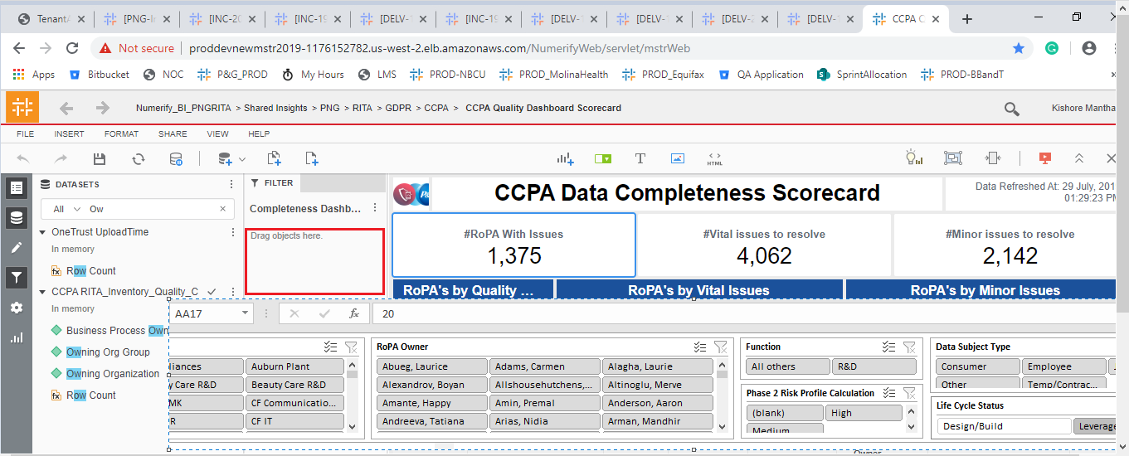

Issue 2:

Clarifications/Observations:

1. Should we need to display the Report Description and Instructions?

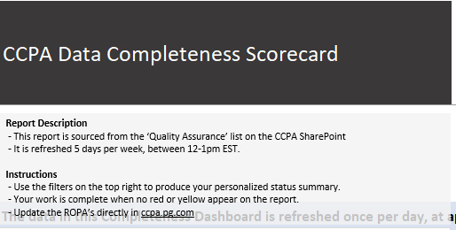

1. Driving Functionality : How the record should be driven?
2. Can we have the Total RoPA KPI.
3. Should we need to calculated the Vital and Minor issues for the Application in Decommissioned also?